WORKSHOP PROGRAMME

2pm – 2.30pm | Registration
2.30pm – 3pm | Exploring Big Data  Faciliated by Prof Alan Murray & Dr James Auger  Speculate on the future products, systems or services that could emerge.
3pm – 4.30pm | Hands-on activities
4.30pm – 5.15pm | Refreshments & Networking
5.15pm | End of Programme

*Programme may be subject to change.

SPEAKERS’ PROFILE
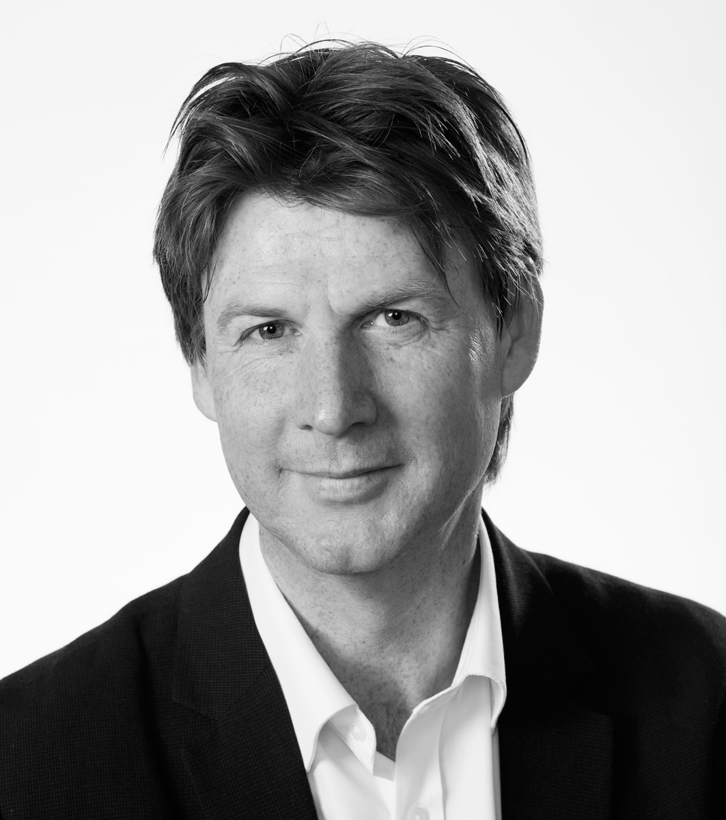

Professor Alan Murray
Deputy Vice-Chancellor, Falmouth University

Alan Murray is Deputy Vice-Chancellor and Professor at Falmouth University. Most recently, he has worked for Edinburgh College of Art at the University of Edinburgh where he was Deputy Principal, Head of the School of Design and Co-Director for the £3.65 million research centre in Design Informatics which he was jointly responsible for. In April 2013, under Alan’s leadership, the University of Edinburgh signed a partnership with Donghua University (formerly the Chinese Textile University) to create the Shanghai College of Fashion and develop leading research in Fashion with the London College of Fashion (London), Bunka (Tokyo) and the Fashion Institute of Technology (New York).

Alan lived in Amsterdam from 1998-2008 and worked at the Design Academy Eindhoven where he was the coordinator of “Man and Leisure” and Director of the “Fun Lab”.
From 2001 Alan was appointed the ‘Director of Design’ at the Technical University Eindhoven (TU/e) and helped build a new faculty of Industrial Design. The goal was to develop a curriculum to create a new type of Design Engineer. To do this a ‘collision’ between Design and Engineering was created to produce a hybrid. Students would document their work and reflect on the development through competency pillars. The Dutch Ministry of Culture funded his work on Instruction Manuals and Guides. This work has been internationally exhibited.

Alan studied Fine Art at Chelsea School of Art and completed his Masters at ‘De Ateliers’ in the Netherlands. He has worked at a number of Universities, notably The Design Academy Eindhoven where he was Director of the ‘Funlab’ and the Technical University Eindhoven where he was Design Director and developed a new faculty of Industrial Design.
His innovative research is institutionally strategic and collaborative and has been widely disseminated through international exhibition, conference and knowledge transfer. Recent exhibitions include; Crafting Narrative: Storytelling Through Objects And Making, Pitzhanger Manor Gallery, Crafts Council (2014); the Angle Gallery; ‘C//Back up’ (2013) Amsterdam, ‘Mixing Business with Pleasure’ (2013); exhibition and symposium at Rom8, Bergen and ‘Synthetic Biology; Where Organic Meets Digital’ a performance as part of the Edinburgh International Festival (2013). With Dr James Auger (RCA) and Jimmy Loizeau (Goldsmiths), Alan is developing ‘Robjects; a complex network of people, products, pets, services, spaces and interactions’. He is Lead Academic on a Knowledge Transfer Partnership developing ‘innovation in community analytics’. From 1997-2007 he developed a ‘guide-to-squash’ which was both an innovative model of online interaction and a piece of performance art. His interests include instruction manuals and guides; cross-disciplinary collaborative research; Intelligent products, systems and services; synthetic biology; international partnerships; strategic review; course design, validation and development; development of academic frameworks and regulations; academic quality assurance.

-------------------------------------------------------------------------------------------------------------------------------

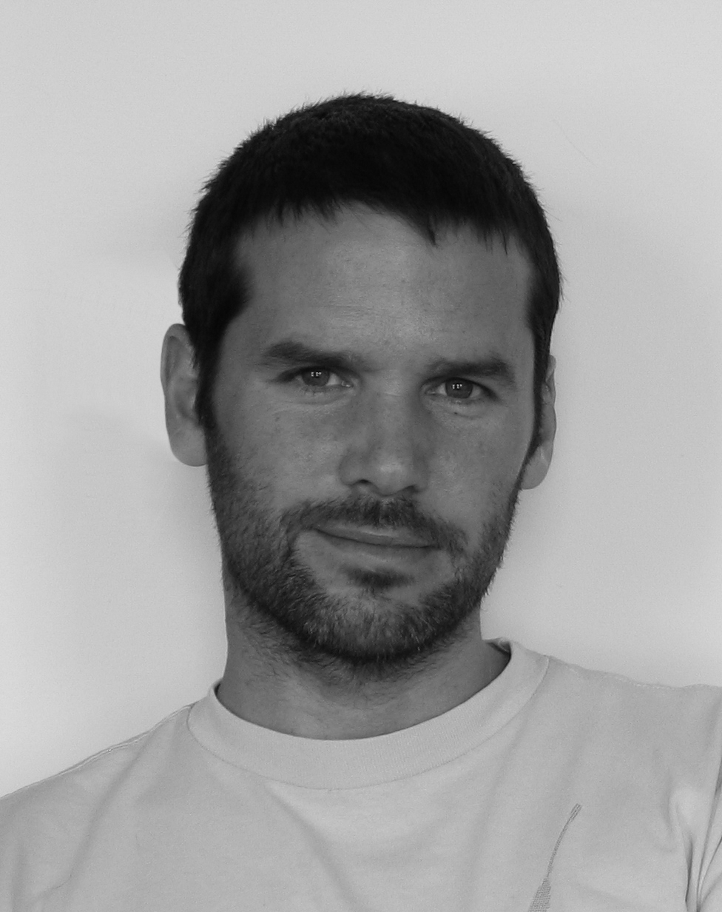
Dr James Auger
Partner, Auger-Loizeau

James Auger is a designer, researcher and lecturer whose work examines the social, cultural and human impact of technology and the products that exist as a result of its development and application.

On graduating from Design Products (MA) at the Royal College of Art in 2001 James moved to Dublin to conduct research at Media Lab Europe (MLE) exploring the theme of human communication as mediated by technology. After MLE he worked in Tokyo as guest designer at the Miyake Design Studio developing new concepts for mobile telephones.

In 2005 he returned to the RCA to teach on the Design Interactions programme. During his time in DI he has been a Philips research fellow exploring the human experiential potential of smell as part of their probes programme (2006-2007) and more recently completed a Ph.D (December 2012). The thesis questions the process through with emerging technologies enter everyday life using the robot as a focus for the study.

James is a visiting professor at both the Haute École d’Art et de Design in Geneva and Musashino Art University in Tokyo.

He is a partner in the speculative design practice Auger-Loizeau whose projects have been published and exhibited internationally, including MoMA, New York; 21_21, Tokyo; The Science Museum, London and Ars Electronica, Linz. Their work is in the permanent collection at MoMA.

Before moving into the field of design James completed an Engineering apprenticeship at Rolls-Royce, Derby (aero engines) and worked for several years as a model-maker and special effects technician in the film industry.

