Liveness 4.0: a new paradigm for accessibility at music festivals.

Adrian Bossey

**Introduction**

There are growing demands for the music festival industry to significantly enhance inclusivity for a range of audiences. This includes increasing accessibility for people who are Deaf or disabled. The use of Information Communication Technologies (‘ICT’) is becoming increasingly central to the way in which many audiences experience music festivals. While digitising performances is contentious, COVID-19 stimulated a proliferation of digitised live music content generation. Audience engagement with remote content may extend to content generated at on-site music festivals and this is likely to be more popular if it is perceived to be authentic as a live experience. ICT offers some potential to increase accessibility to live musical performances. However, ICT needs to be sensitively deployed when supplementing ‘as live’ content, to avoid “any risk of creating new instances of exclusion at music festivals” (Bossey, 2020: 22).

This chapter analyses existing literature and builds on previous enquiry to inform conceptual research, which can represent “a powerful means of theory building” (Jaakkola 2020: 18) to connect concepts together relationally (Reese, 2022). In doing so it responds to a recommendation from Wilson et al., (2017: 206) that “festival studies embrace greater methodological diversity”. The author considers liveness, authenticity, communitas and performance futures in relation to ICT enhanced content generated by music festivals to improve accessibility for people who are Deaf or disabled. Responding to “Industry 4.0” (Schwab, 2016) a new conceptualisation of ‘liveness 4.0’ is proposed to incorporate the concept of the Fourth Industrial Revolution. The chapter further questions whether a new paradigm of ‘liveness 4.0’ is required to consider audience experiences facilitated by emerging ICT, which aim to increase accessibility for people who are Deaf or disabled at music festivals.

A case study on the Beat Blocks haptic flooring system is included as a novel example of developing accessibility at events. This considers respondent’s perceptions of liveness in relation to a range of viewpoints and perceptions of liveness, authenticity and communitas regarding haptic flooring technology.

**Key concepts regarding ICT enhanced performances at music festivals**

Music festivals are “concerts, usually outdoor, often held over several days” Shuker (2012: 130) and can be considered as “part of the fabric of global society” (Davies, 2021: 185). Audiences are predominantly motivated to attend for social and personal reasons (Mulder and Hitters, 2021), with 35.3 million people visiting UK outdoor music events in 2018 (Jackson et al., 2019). In America, the Nielsen Music's 2018 ‘Music 360 Report’ stated that more than 52 percent of the US population attend live music events (Rys, 2018) and in Europe 20.9 million people attended music events in during the same year (Statista, 2021). Feelings of belonging are created at time-limited music festivals through “communitas” (Turner, 1969: 94). This temporary “psychological sense of community” (Jahn et al., 2018: 329) may motivate music festival attendances (Wu et al., 2020) and stimulate intense shared emotional reactions to performances which are “sometimes overwhelming” (Karlsen, 2016: 115). Ideally, music festival attendees will experience inclusive collective celebrations (Banke and Woodward, 2020).

Under The Equality Act (2010) UK music festivals must not discriminate due to ‘protected characteristics’ including age, race, gender and disability. In the UK, 14.6 million people were identified as having a disability in 2020/21 (House of Commons Library, 2022). Their rights to “take part on an equal basis with others in cultural life” are recognised by Article 30 of the UN Convention on the Rights of Persons with Disabilities (United Nations, 2006). However, music festivals may generate social exclusion (Duffy et al., 2019) which can further increase “when a person belongs to several different groups, each of which is subject to discrimination” (Steinfeld and Maisel, 2012: 183).

In this context, accessibility can be defined as “measures put in place to address participation by those with impairments” (Finkel et al., 2019: 2). In some circumstances, it may be facilitated by accessible technology which can be “utilised effectively” by people who are Deaf or disabled (Lazar, et al., 2015: 18). This could include hearing loops, which provide a magnetic, wireless signal for hearing aids (Hearing Link Services, 2023) or well-presented immersive subtitles which “can contribute to a higher e-inclusion” (Hughes et al., 2019: 4). Indeed, these bespoke ICT developments have already proved valuable in increasing accessibility for people who are Deaf or disabled and further advancements “should be seized” (Alvarado, 2022: 214). Deafness encompasses a range of sound experiences including accessing music at specific volumes or registers and feeling vibrations (Cornelius and Natvig, 2023). Clearly, individual levels of hearing loss dictate what may be accessible for each audience member who identifies as Deaf or hearing impaired (British Deaf News, 2022: 5).

Despite the centrality of music, visiting a music festival is an immersive experience, “addressing not only the auditory but the whole of perception” (Lell, 2019: 66). A broad range of equipment and resources used to “transmit, store, create, share or exchange information” (UNESCO, 2019: 1) can be described as ICT. Technologies develop over time and “Industry 4.0” (Schwab, 2016: 12) describes a fourth industrial revolution whereby new technologies interact across digital, physical, and biological fields. According to the Sensory Trust (2020) the “big five” senses of sight, hearing, smell, taste, and touch can be augmented with heat, pain, balance, and the perception of body awareness.

In 2015, a conceptual article envisaged a possible future for music festivals whereby haptic technologies would apply vibrations to stimulate the sense of touch “literally allowing participants to feel the music” (Robertson et al., 2015: 580). Several haptic products are now becoming available to enhance engagement with content at/from music festivals. These include Vest 3, designed to “vibrate precise frequencies throughout your entire body” (Woojer, 2023: 1) and the Beat Blocks multi-sensory interactive flooring system, designed to produce an “accessible tactile experience for audiences with sensory impairments” (Beat Blocks, 2023: 2). The band Coldplay supplied haptic vests at their last tour (Payne, 2022) and haptics can also be deployed for use at hybrid and virtual events, and may become essential for events in the metaverse.

By incorporating haptic or other ICT enhancements, on-site music festivals featuring ‘live’ content can be considered as hybrid events which include both ‘in-person’ and virtual elements. Continued growth in ICT enhanced performances may both increase the number of such hybrid events and provide additional opportunities to grow inclusion across all excluded groups at (previously solely) on-site music festivals. Furthermore, livestreaming performances “accesses audiences that are not reached by live concerts in physical venues” (Haferkorn et al., 2021: 5) to provide content for hybrid or virtual events. Virtual communities can develop social co-presence described as “online liveness” (Couldry, 2004: 356) through use of ICT, which can create an experience of communitas around music festivals “for all who engage in this way” (Brown et al., 2019: 25). Online participation in hybrid events can facilitate some “random, unpredictable and tangential experiences” (Green, 2023: 16) that form part of the music festival experience. Responding to growing use of ICT enhancements to live music content, Bossey (2020) recommended further research into tensions between accessibility for audience members who are Deaf or disabled and notions of “liveness” at music festivals.

Liveness is “the quality or state of being live” (Merriam-Webster Dictionary, 2023) and has been discussed across a range of mediums including television, theatre, and live music. By extension, it could apply to other genres of events. It requires the presence of both audience members and performers, however whether all parties need to be physically co-located at a moment in time is the source of debate within the academic discipline of performance studies. There are two main conflicting viewpoints regarding ‘liveness’ in performance. Phelan (1993:146) suggested that “performance’s only life is in the present (it) cannot be saved, recorded (or) documented”, implying that live music requires the physical, geographical, and timely co-presence of musician and audience (Tsangaris, 2020). More recently, Auslander (2008:109) stated that liveness “is not an absolute condition” so performances may include both live and ICT enhanced elements. Despite initially questioning whether liveness is primarily an attribute of a performance being experienced, or the perception of its audience, Auslander (2012) later discounted this. Identifying digital liveness as a particular way of “being involved with something” (Auslander, 2012: 10) wherein audiences experience liveness when they consciously accept ICT enhanced performances as live in response to their positioning as being live.

According to Dixon et al., (2015: 125) the liveness argument “pivots around oppositional ideological positions privileging the live over the mediatised or vice versa.” The enhanced value of live recordings for online memorialisation in the “aftermath of the concert” was proposed by Long (2016: 158) and Phelan’s perspective persists amongst some music industry ‘gatekeepers’ (Bossey, 2019). This is aligned with traditional notions of shared experiences created during “face-to-face meetings between artist and fan” (Bennett, 2015: 3). However, a ‘mixed economy’ is emerging, so, for example, within opera, Ouazzani et al., (2023) identify some benefits in ICT enhanced performances whilst simultaneously adopting elements of Phelan’s (1993) notion of ‘classic liveness’ by regarding streamed experiences as less social. Other academics perceive more extreme changes of perception, Mallinder (2020) considers that ‘live’ could now mean a virtual event free of restrictions of time and place. Sanden (2019: 180) proposes a category of ‘virtual liveness’ to describe mediated experiences and considers liveness to be functioning in this scenario as a “conceptual and perceptual” signifier. Perceptions change over time, with technology, so Kim (2017: 5) states that “what distinguishes this age from its precursors is the ways computing devices can create an interface between producers and consumers of performance frequently and intensely, so as to generate a new paradigm of liveness”.

**Application to virtual and hybrid events**

This chapter applies theoretical research to discuss theories relating to liveness in music performances and Schwab’s (2016) concept of ‘Industry 4.0’. In particular it focusses on haptic technologies which can be deployed in music venues or at home to attempt to increase accessibility to music festivals for people who are Deaf or disabled through hybrid or virtual events.

While music festivals may be exclusive (Duffy et al., 2019), their duty not to discriminate against protected characteristics compels organisers to act proactivity to achieve Alvarado’s (2022) desired advancements in accessibility. The adoption of accessible technology to support people who are Deaf or disabled (Lazar et al., 2015) implies that additional aspects of the live music experience are required by audience members who are Deaf or disabled to achieve equity of live experience. These audience members may require the co-presence of musician and audience as envisaged by Phelan (1993), whilst simultaneously accepting ICT enhanced performances as being live, as envisaged by Auslander (2012) and agreed by the author in relation to some audiences for some ICT enhanced performances.

By adopting an Oxford English Dictionary definition of “liveness” describing “a performance, heard or watched at the time of its occurrence, as distinguished from one recorded on film, tape, etc”, Auslander (2008: 56) predominantly positioned his theory to differentiate between ‘recorded’ and live’ performances. This approach aligns with other performance studies academics including Dixon et al., (2015) and Sanden (2019), who mainly describe the mediatisation of live content via ICT emanating from the third ‘digital’ industrial revolution, including the internet and relating to the senses of sight and hearing. Auslander (2012) and others can therefore be characterised as predominantly considering a state of ‘liveness 3.0’. Conversely, haptic technologies pertaining to sense of touch (Sreelakshmi and Subashb, 2017) can be contextualised as belonging to the concept of “Industry 4.0” (Schwab, 2016: 12) within hybrid and virtual events. Innovation pertaining to the senses of taste, smell, heat, or body location may also inform the ICT enhanced future of music festivals and other hybrid or virtual events.

Building on Kim’s contention (2017) that a new age brings a new paradigm of liveness, it is proposed that a new concept of ‘liveness 4:0’ is required to consider ICT enhanced augmentation in both physical and biological domains. Mediatisation through new technologies can potentially impact on a greater range of senses than a performance which has not been enhanced. Viewpoints can be created whereby an audience member is simultaneously enacting Phelan’s (1993) face to face engagement with a performer and benefitting from ICT enhancements which add new facets to the live performance, for instance through haptic technology. Further augmenting a live performance as opposed to enhancing what already exists through, for instance, hearing loops. This could potentially, create a more inclusive position and one which is closer to equity of experience of classic liveness, for some people who are Deaf or disabled. In this way, ICT enhancements emanating from the technologies of ‘Industry 4.0’ may enable a higher state of liveness than can be achieved via the simple, un-augmented face-to-face interaction between performer and audience member envisaged within Phelan’s (1993) ‘classic liveness’. Additionally, potential exists to increase audience perceptions of liveness within virtual events by introducing physical or biological sensations.

Adoption of a ‘liveness 4.0’ based approach builds upon existing theories regarding liveness from Auslander (2012), Sanden (2019), and Mallinder (2020), to enable a contemporary consideration of liveness pertaining to performances across all mediums of live performance, including hybrid and virtual formats. Given the role of ICT in building communitas at music festivals (Brown et al., 2019) consideration of factors which surpass the simplified relationship between audience member and performer are also required to ascertain contemporary liveness. Unplanned and indirect experiences can be central to the music festival experience, as an important element to building communitas. Given that these are now achievable via online engagement (Green 2023), incorporating perceptions of communitas into considerations of liveness at music festivals is important. Conversely, exclusion from feelings of communitas due to challenges around engaging with both on-site experiences and ICT are relevant to help fully conceptualise liveness for people who are Deaf or disabled.

Perceptions of liveness relating to relevant bespoke ICT products which aim to improve accessibility for people who are Deaf or disabled are likely to impact upon their adoption. This will likely occur within physical, hybrid and virtual formats regardless of any previous experience that respondents may have of using the ICT in question. To better understand the likely uptake of digital, physical, and biological augmentations to live music, there is therefore undoubted value in testing audience perceptions through case studies of individual technologies.

**Case study – Beat Blocks**

From the fourth to the eighth of October 2022, the Beat Blocks multi-sensory interactive haptic flooring system was installed as part of the Roundhouse, London, at Vice UK's Rising Festival (see image 1 and 2). Seven tiles from the system were fitted in the venue’s Studio Theatre, which hosted the BBC Introducing Stage, so that audience members could experience haptic technology during performances, if they chose to. A small, pilot case study was carried out on the evening of the seventh of October 2022. This explored audience perceptions regarding the degree to which Beat Blocks enhanced their appreciation of a performance, sense of communitas, sense of inclusion and feelings of authenticity in terms of ‘liveness’ relating to a music performance.

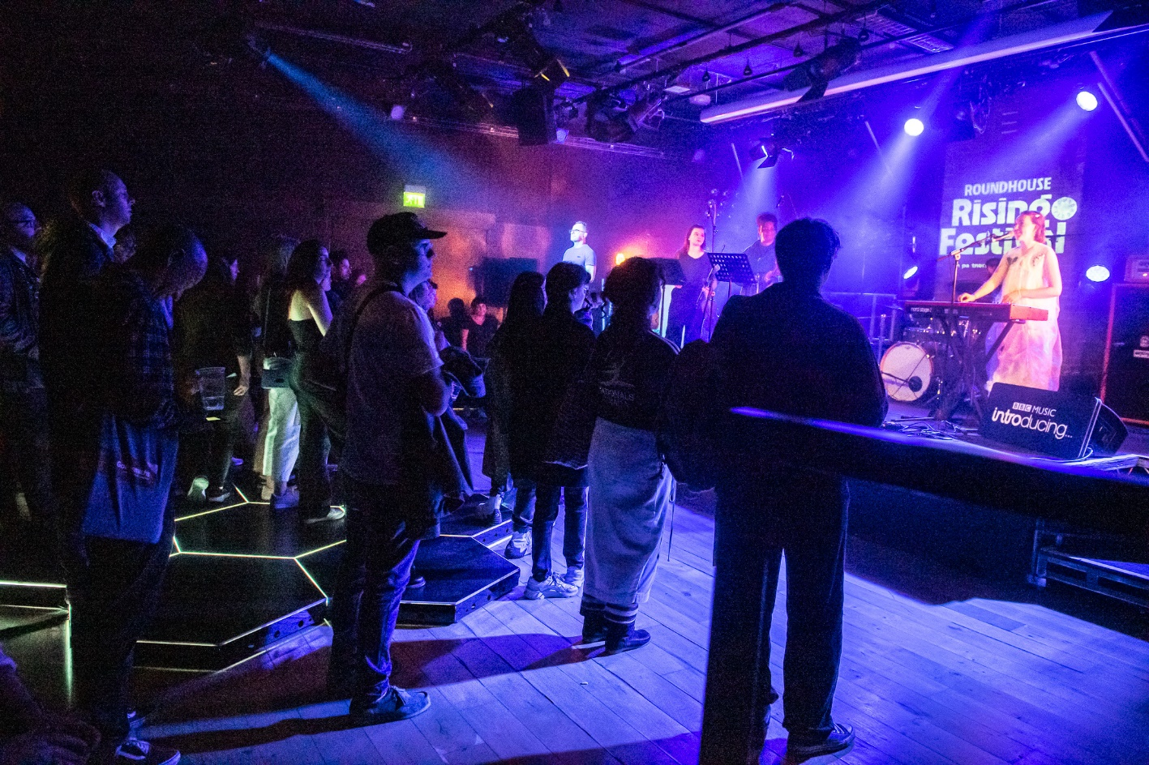

Image - Beat Blocks flooring system (© Rah Petherbridge)

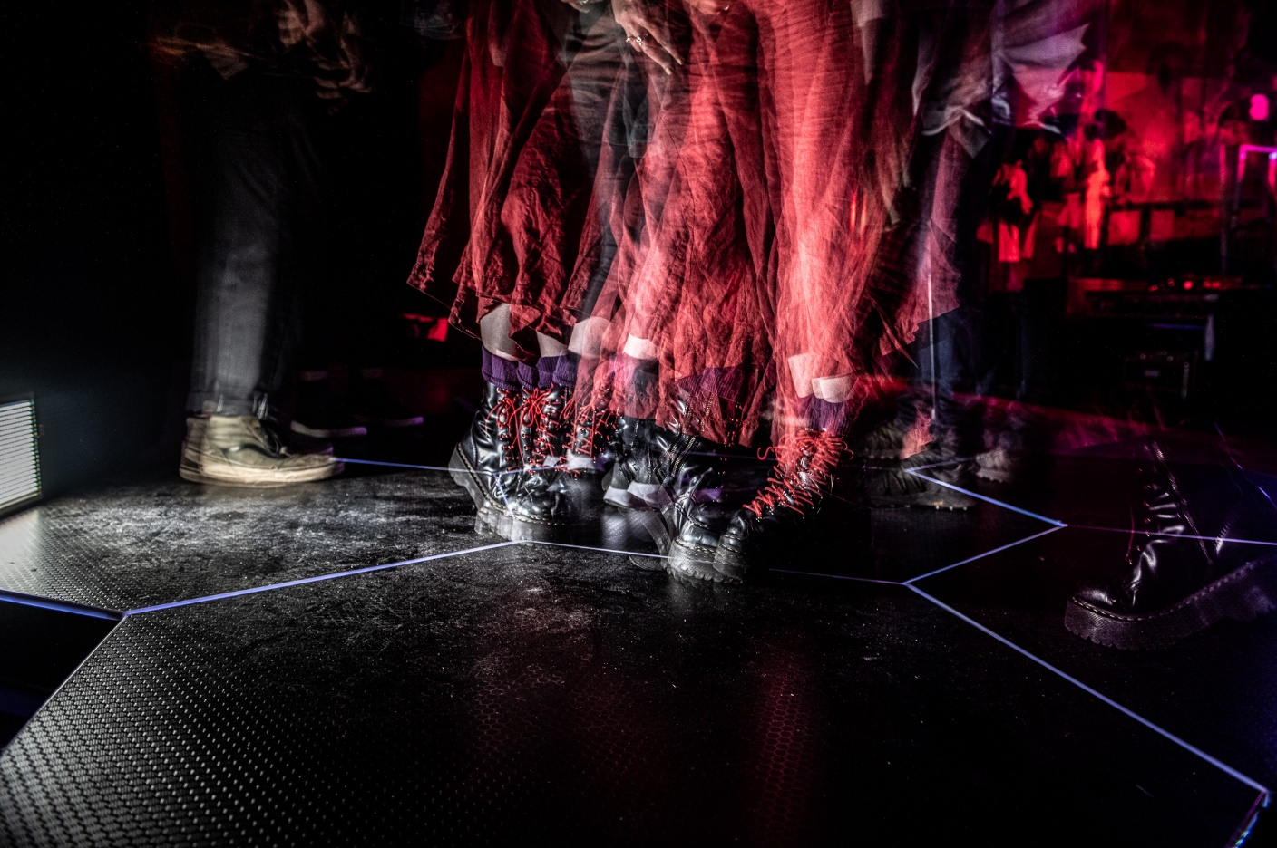

Image 2 - Beat Blocks flooring system in use (© Rah Petherbridge)

Closed questions elucidated quantitative information using seven-point Likert scales, which were collapsed to ensure sufficient sample size (Fox et al., 2014). The first scale utilised a revised version of a previously devised scale of liveness in performances at, or emanating from, music festivals to ascertain a general perception of liveness from selected audience viewpoints. These considered a spectrum of experiences from predominantly watching the performers on-stage during the performance, to using handheld devices, watching screens at the side of the stage, utilising immersive subtitles, hearing loops and additional sensory augmentation. The second scale asked respondents to indicate the extent to which they agreed with a range of statements regarding the Beat Blocks haptic flooring system, to explore whether the system increased perceptions of artistic appreciation, communitas, inclusion or liveness. Outcomes were coded with agreement corresponding to ‘acceptance’ and disagreement corresponding to ‘resistance’ under the early stages of the consumer innovation decision process (Nabih et al., 1997).

Over 45% of respondents had experienced a live performance augmented with the Beat Blocks flooring system. Predominantly watching the performers on-stage achieved the highest acceptance (97.6%). Watching the performers on-stage while experiencing other additional sensory augmentation was next highest (71.8%) while experiencing other additional visual augmentation had 71.1% acceptance. These sets of responses exhibited a significant increase in acceptance where respondents stated they had experienced the flooring system. This is potentially encouraging in terms of audience adoption of haptic technologies. It is interesting to reflect on ‘liveness 4.0’ in relation to both these findings and acceptance of using a handheld device to watch/film the performance being lowest (40.5%).

Acceptance regarding the Beat Blocks haptic flooring system was distributed unevenly: Enhancement of appreciation of the musical performance (82.4%), experiencing an authentic live music performance (74.2%) and sense of inclusion during the performance (72.8%) were high. Acceptance that the flooring system would positively influence future decisions to attend performances (82.3%) may indicate a significantly positive level of perception. Whilst these results appear supportive of the haptic flooring system and could partially corroborate the need for a new paradigm of ‘liveness 4.0’, the research is limited by the small number of respondents and consideration of one medium and example of liveness.

**Conclusions and opportunities for events**

Despite representing a very significant potential audience demographic, people who are Deaf or disabled are often excluded from music festivals. UK music festival organisers have a legal duty not to not discriminate on the grounds of disability. Therefore, organisers should consider all potential mitigations to increase accessibility. ICT enhancements have significant potential in this regard and are increasingly re-positioning on-site music festivals as hybrid events by default. The introduction of virtual elements to a range of event types featuring performances has potential to enhance the audience experience for a wide range of audience demographics and should therefore be seriously considered by event managers and performers. However, ICT enhanced performances must be deployed sensitively and in a manner which feels ‘live’.

It is agreed that some audiences do consciously accept some ICT enhanced performances as live (Auslander, 2012). However, Auslander (2012), Dixon et al., (2015), and Sanden (2019), and other academics researching the field of performance studies, predominantly differentiate between ‘recorded’ and live’ performances utilising ICT emanating from the third ‘digital’ industrial revolution, relating to the senses of sight and sound. This conceptual research contributes to theory building (Jaakkola, 2020) for music and other performances, by proposing that academics should now consider a state of ‘liveness 4.0’ in response to Schwab’s (2016) theory of industry 4.0. Wherein ‘liveness 4.0’ extends consideration of liveness to include audiences interacting with performances across digital, physical, and biological domains. This new paradigm of liveness (Kim, 2017) incorporates haptic technologies, which have potential to augment live performances so that they include the sense of touch, which would not usually be considered by most audience members as being part of a live music performance. This higher state of augmented live performance experience can occur under the conditions described ‘in the moment’ within Phelan’s (1993) concept of ‘classic liveness’.

Clearly, ‘Industry 4.0’ based ICT augmentation has great potential to increase accessibility to music festivals for people who are Deaf or disabled. Furthermore, haptic technologies may be particularly beneficial for people who identify as being Deaf or hearing impaired. Events professionals are encouraged to explore the direct application of ICT augmentation into their existing on-site event provision to transition them into hybrid events and increase inclusion. Furthermore, the process can potentially work ‘in reverse’ through the incorporation of on-site elements to virtual events such as on-line music festivals. This could be calibrated to facilitate enhanced audience experiences for (lone) individual users as well as in communal settings. It is contended that thorough consideration of ‘liveness 4.0’ should therefore become an important element of best practice when planning and delivering music festivals and other hybrid or virtual events.

However, the use of haptic technologies in this regard is currently under researched. The initial case study of the Beat Blocks haptic flooring system described herein is offered by way of example and contains some limited evidence of some positive audience perceptions of the liveness of music performances augmented with haptic flooring. There is scope for further research into audience perceptions of the liveness of performances augmented by haptic and other ‘Industry 4.0’ technologies. This could occur in part through case studies of individual products at music festivals which include greater numbers of respondents. It is hoped that both organisers of music festivals and academics researching in this field are encouraged to further explore potential ICT augmentation of music performances and perceptions of liveness in this regard.

It is concluded that a new paradigm of ‘liveness 4.0’ is required to consider haptic technologies designed to increase accessibility for people who are Deaf or disabled at music festivals. Furthermore, ‘liveness 4.0’ can incorporate ICT augmentations relating to audience members senses of smell, taste, heat, balance, and perception of body awareness. Haptic and other ‘industry 4.0’ related ICT has great potential for increased adoption within virtual and hybrid events across music and a range of other event genres. It is therefore contended that ‘liveness 4.0’ will be an important consideration for event organisers looking to maximise existing audiences and grow new ones for virtual and hybrid events. People who are Deaf or disabled represent a significant, growing audience/potential audience segment for the global live events sector, which is experiencing rapid speed of change. Within this context, event organisers should regularly ‘future scan’ for emerging ICT enhancements with potential to be perceived as delivering an authentic live experience to their audience.

**References**

Alvarado, K. (2022). ‘Accessibility of music festivals: a British Perspective’*, International Journal of Event and festival management*, **13** (2), 203-218.

Auslander, P. (2008). *Liveness – Performance in a Mediatized Culture*. Routledge.

Auslander, P. (2012). ‘Digital Liveness: A Historico-Philosophical Perspective’, *A Journal of Performance and Art*, **34** (3), 3-11.

Banke, S., & Woodward, I. (2020). ‘Making and Re-Making Public Spaces: The Co(Vid)-Creation of Music Festivals’, *The European Sociologist*, **45** (1).

Beat Blocks. (2023). *The Beat Blocks Experience,* Beat Blocks, accessed 09/01/23. <https://www.beatblocks.co.uk/>

Bennet, R.J. (2015). *The Digital Evolution of Live Music*. Chandos Publishing.

Bossey, A. (2019). ‘Industry perceptions of potential digital futures for live performance in the staging and consumption of music festivals’, in Mair, J. (eds). *The Routledge Handbook of Festivals*, Routledge, 406-416.

Bossey, A. (2020). ‘Accessibility All Areas? UK live music industry perceptions of current practice and Information and Communication Technology improvements to accessibility for music festival attendees who are Deaf or disabled’, *International Journal of Event and festival management*, **11** (1), 6-25.

British Deaf News. (2022). *How do D/Deaf people experience music?*, British Deaf News, accessed 20/02/23. [https://www.britishDeafnews.co.uk/Deaf-people-experience-music/](https://www.britishdeafnews.co.uk/deaf-people-experience-music/)

Brown, A., Donne, K., Fallon, P., & Sharpley, R. (2019). ‘From headliners to hangovers: Digital media communication in the British rock music festival experience’, *Tourist Studies*, **20** (1), 75–95.

Cornelius, S. & Natvig, M. (2023). *Music: A Social Experience*. Routledge.

Couldry, N. (2004). ‘Liveness, “Reality,” and the Mediated Habitus from Television to the Mobile Phone, *The Communication Review*, **7** (4), 353-361

Davies, K. (2021). ‘Festivals Post Covid-19’, *Leisure Sciences*, **43** (1-2), 184-189

Dixon, S., Malina, R., & Cubitt, S. (2015). *Digital Performance: A History of New Media in Theatre, Dance, Performance Art, and Installation*, MIT Press.

Duffy, M., Mair, J. & Waitt, G. (2019). ‘Addressing community diversity: the role of the festival encounter’, in R. Finkel, B. Sharp & M. Sweeney (eds.), *Accessibility, Inclusion, and Diversity in Critical Event Studies,* Routledge, 9-20.

Equality Act. (2010). *Equality Act 2010,* Legislation.gov.uk, accessed 09/01/23. <https://www.legislation.gov.uk/ukpga/2010/15/contents>

Fox, D., Gouthro, M., Morakabati, Y., & Brackstone, J. (2014). *Doing Events Research – From theory to practice*. Routledge.

R. Finkel, R., Sharp, B., & Sweeney, M. (2019). *Accessibility, Inclusion, and Diversity in Critical Event Studies*. Routledge

Green, N. (2023). ‘Splendour XR: Place, Experience and Liveness at a Virtual Music Festival’, *Leisure Sciences - An Interdisciplinary Journal*, 45.

Haferkorn, J., Kavanagh, B., & Leak, S. (2021). *Livestreaming Music in the UK, A Report for Musicians*, Livestreaming Music, [www.livestreamingmusic.uk](http://www.livestreamingmusic.uk)

Hearing Link Services. (2023). *What is a Hearing Loop*, Hearing Link, accessed 13/02/23. <https://www.hearinglink.org/technology/hearing-loops/what-is-a-hearing-loop/>

House of Commons Library. (2022). *UK disability statistics: Prevalence and life experiences,* House of Commons Library, accessed 10/01/23. <https://commonslibrary.parliament.uk/research-briefings/cbp-9602/>

Hughes, C., Montagud, M., & Pesch, P. (2019). ‘Disruptive approaches for subtitling in immersive environments’, *TVX '19: Proceedings of the 2019 ACM International Conference on Interactive Experiences for TV and Online Video*, June 2019, 216–229.

Jaakkola, E. (2020). ‘Designing conceptual articles: four approaches’, *AMS Review*. **10**, 18-26.

Jackson, C., Blake, A., & Hibbert, J. (2019). *Value of Outdoor Events 2018 (UK).* Events industry Forum/Bournemouth University. <https://www.eventsindustryforum.co.uk/images/documents/EIF_summary_report_final.pdf>

Jahn, S., Cornwell, B., Drengner, J., & Gaus, H. (2018). ‘Temporary communitas and willingness to return to events’, *Journal of Business Research*, **92**, 329-338.

Karlsen, S. (2016). ‘Context, Cohesion and Community: Characteristics of Festival Audience Members Strong Experiences with Music’, in Burland, K., & Pitts, S. (eds). *Coughing and clapping: investigating audience experience*, Routledge.

Kim, S-Y. (2017). *Liveness: Performance of Ideology and Technology in the Changing Media Environment*. Oxford University Press.

Lazar, J., Goldstein, D., & Taylor, A. (2015). *Ensuring Digital Accessibility Through Process and Policy.* Elsevier.

Lell, P. (2019). ‘Understanding World Music Festivals as Sites of Musical Education – An Ethnographic Approach’, *IASPN Journal*, **9** (1), 56-72.

Long, P. (2016). ‘Warts and All: Recording the Live Music Experience’, in Burland, K., & Pitts, S. (eds). *Coughing and clapping: investigating audience experience*, Routledge.

Mallinder, S. (2020). ‘Live or Memorex. Changing perceptions of music practices’, in Jones, A., & Bennett R. (eds), *The Digital Evolution of Live Music*. Elsevier, 55-70.

Merriam-Webster Dictionary. (2023). *Liveness*, Merriam-Webster.com, accessed 14/02/23. <https://www.merriam-webster.com/dictionary/liveness>

Martijn Mulder, M., & Hitters, E. (2021). ‘Visiting pop concerts and festivals: measuring the value of an integrated live music motivation scale’, *Cultural Trends*, **30** (4), 355-375.

Mohamed I. Nabih, M., Bloem, J., & Poiesz , T. (1997). ‘Conceptual Issues in the Study of Innovation Adoption Behavior’, *Advances in Consumer Research*, 24, 190-196.

Ouazzani, Y., Calderón-García, H., Tubillejas-Andrés, B., & Cervera-Taulet, A. (2022). ‘Perceived Value of the Opera Experience in the Real and Virtual Spheres: Dimensions that Make the Difference’, *International Journal of Arts Management*, **25** (1), 37-52.

Payne, O. (2022). *Coldplay are giving Subpacs to Deaf and hard of hearing fans at live shows*, Musictech, accessed 13/02/23. [https://musictech.com/news/events/coldplay-are-giving-subpacs-to-Deaf-and-hard-of-hearing-fans-at-live-shows/](https://musictech.com/news/events/coldplay-are-giving-subpacs-to-deaf-and-hard-of-hearing-fans-at-live-shows/)

Phelan, P. (1993). *Unmarked: The Politics of Performance*. Routledge.

Reese, S. (2022). ‘Writing the Conceptual Article: A Practical Guide’, *Digital Journalism*.

Robertson, M., Yeoman, I., Smith, K. A., & McMahon-Beattie, U. (2015).’Technology, society, and visioning the future of music festivals’, *Event management*, **19** (4), 567-587.

Rys, D. (2018). *Nielsen Releases In-Depth Statistics on Live Music Behavior: 52 Percent of Americans Attend Shows*, Billboard, accessed 24/03/23. <https://www.billboard.com/pro/nielsen-releases-in-depth-statistics-live-music-behavior-360-report/>

Sanden, P. (2019). ‘Rethinking Liveness in the Digital Age’, in Cook, N., Ingalls, M., & Trippett, D. (eds). *The Cambridge Companion to Music in Digital Culture*. Cambridge University Press, 178 – 192.

Schwab, K. (2016). *The Fourth Industrial Revolution: What It Means and How to Respond. Geneva,* World Economic Forum. <https://www.weforum.org/agenda/2016/01/the-fourth-industrial-revolution-what-it-means-and-how-to-respond/>

Sensory Trust. (2020). *How many senses do we have?,* Sensory Trust, Accessed 23/03/23. <https://www.sensorytrust.org.uk/blog/how-many-senses-do-we-have>

Shuker, R. (2012). *Popular Music Culture – The Key Concepts*. Routledge.

Sreelakshmi, M., & Subash, T. (2017). ‘Haptic Technology: A comprehensive review on its applications and future prospects’, *Materials Today: Proceedings*. **4** (2), 4182-4187.

Statista. (2021). *Attendance at live events taking place at arenas in Europe in 2018, by genre,* Statista, accessed 23/03/23. <https://www.statista.com/statistics/783267/live-events-attendance-by-genre-in-europe/>

Steinfeld, E., Maisel, J. (2012). *Universal Design: Creating Inclusive Environments*, John Wiley & Sons.

Turner, V. (1969). *Liminality and Communitas. In The ritual process*: Structure and anti-structure. Cornell University Press.

UNESCO Institute for Statistics. (2019). Data for sustainable development goals, UNESCO, accessed 11/02/23. <http://uis.unesco.org/en/glossary-term/information-and-communication-technologies-ict>

United Nations. (2006). *Convention On The Rights Of Persons With Disabilities*, United Nations, accessed 08/01/23. <https://www.un.org/development/desa/disabilities/convention-on-the-rights-of-persons-with-disabilities.html>

Wilson, J., Arshed, N., Shaw, E., & Pret, T. (2017). ‘Expanding the Domain of Festival Research: A Review and Research Agenda’, *International Journal of Management Reviews*, **19** (2), 195-213.

Woojer. (2023) *Woojer Vest 3,* Woojer, accessed 09/01/23. <https://www.woojer.com/products/vest-3>

Wu, S., Li, Y., Wood, E., Senaux, B., & Dai, G. (2020). ‘Liminality and festivals—Insights from the East’, *Annals of Tourism Research*, **80**.