***‘Moving forward sustainability theory, research and practice’* Panel at GEI 2023 - MEDIA STORIES:**

<https://accessaa.co.uk/agf-announces-full-agenda-for-green-events-innovations-conference/>

<https://www.festivalinsights.com/2023/03/agf-rebrands-delivers-sold-gei/>

<https://www.eventindustrynews.com/news/festival-outdoors/agf-announce-full-agenda-for-green-events-innovations-conference-adapting-to-the-new-climate>

<https://35.ilmc.com/gei/>

AEME WEBSITE STORY:

<https://www.aeme.org/sustainabilitysig>

Written by AEME Sustainability SIG Lead Dr Mary Beth Gouthro

For further info contact: [mgouthro@bournemouth.ac.uk](mailto:mgouthro@bournemouth.ac.uk)

AEME members were pleased to take part in an Education panel at GEI15 (Green Events & Innovations) recently at the Royal Lancaster Hotel in London on February 28th 2023.  The UK’s foremost conference for sustainability at live events is in its 15th year and held in conjunction with AGF (A Greener Future).  Sessions cover green matters related to transport, energy, food, equality, inclusivity and climate justice to name a few.  Invited by GEI organisers AGF, four AEME institution members made up of five academics compiled the panel entitled ‘Moving forward sustainability theory, research and practice’.  Led by AEME chair Adrian Bossey of Falmouth university, other panel members included Professor Jane Ali-Knight of Edinburgh Napier University, Clare Mackay and Briony Whitaker from UWE (University of West of England) and Daniel Baxter of Glasgow Caledonian University.

The AEME panel was able to share their experience of sustainability research and practice to a diverse audience of event professionals working in green practice.  The panel shared their research practice with the audience that included ie collaboration between AGF and festivals in Mexico (Jane), and the relevance of environmental self-identity and attitude behaviour at Boomtown festival (Clare).  Briony shared some of her work on how festival goers view environmental incentives at Shambala and the shaping of proposals for sustainable interventions in these spaces.  Daniel shared his work social sustainability of RuPaul events and importance of creating safe spaces.  Panel Chair Adrian also shared his research on the use of haptic floors at deaf raves in reaching an inclusive festival audience.

​

AEME chair Adrian Bossey sees the panel contribution to GEI15 as a prime opportunity to build dialogue and work with industry further to progress awareness and good practice.   Clare Mackay, Programme Leader for the MSc in Events Management at UWE added that she hopes some of the GEI the delegates will be interested to explore how they can collaborate with AEME members for the benefit of their organisations, us as AEME members, and our students.  Daniel Baxter, Senior Lecturer of International Tourism and Events Management at Glasgow Caledonian University also saw AEME’s presence as being able to explore ways to connect better with industry to innovative sustainable practices.  This includes ensuring students are included in this process showing that there is so much opportunity universities and industry to work to meet the challenges of sustainability within the events and festival sectors.

A Greener Festival Director Teresa Moore said this was the first time they’ve invited a dedicated panel for academics to talk about their event and sustainability research at their annual conference GEI, ‘The panel provided an opportunity for our audience of industry specialists to gain an insight into current research in the field and to make connections with researchers and academic institutions’.  She said AGF Conference organisers were delighted by delegate reaction to the AEME panel, with AEME very much looking forward to participating in a similar way at GEI again in the future.

​

​

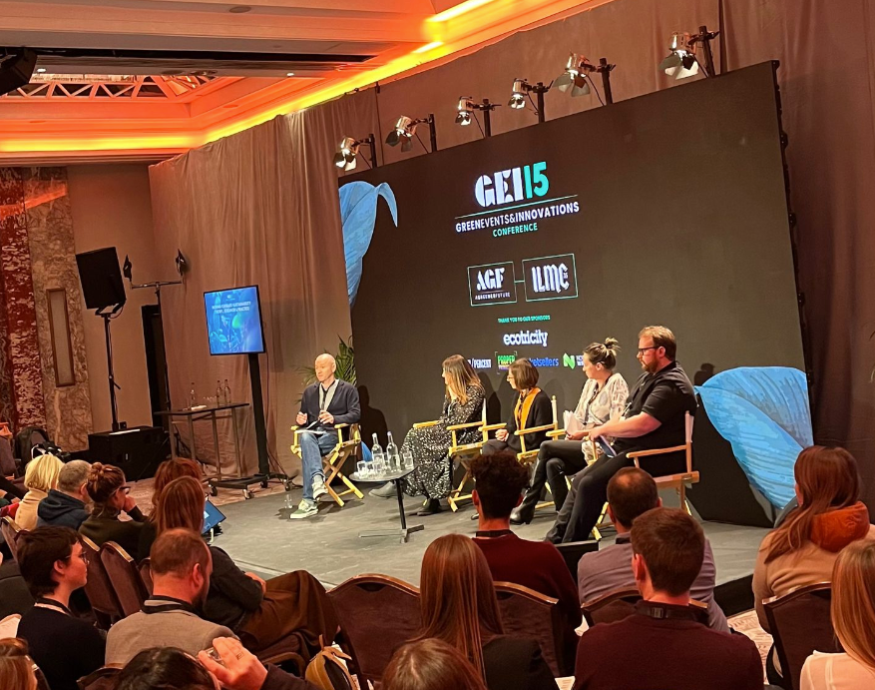

* [](https://twitter.com/AEME_EventsEd)
* [LinkedIn](https://www.linkedin.com/company/aeme-events-ed/)

© 2023 by AEME